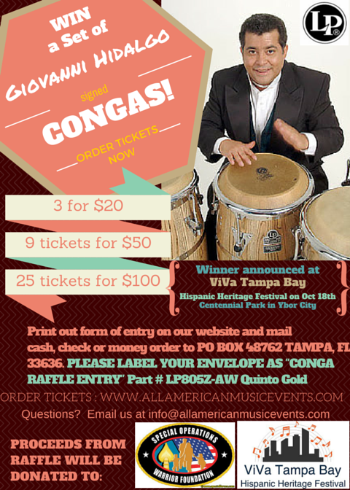

Grammy award winner Giovanni Hidalgo conga raffle submission form
Online submission directions: Complete information on form with receipt number and email to info@allamericanmusicevents.com
Mail in Submissions: Please print out form, complete and send check or money order to:
ViVa Tampa Bay
Giovanni Raffle Submission
PO BOX 48762
TAMPA, FL 33646

Name: _______________________________ Date:______________

Address:__________________________________________________

Contact phone number: ______ _______ ______
Please mark the number of tickets you would like to purchase:

_____ 3 tickets for $20.00
_____ 9 tickets for $50.00
_____ 25 tickets for $100

Reciept # (only use if paying online) ___________________________
WINNER WILL BE ANNOUNCED BY 4PM AT VIVA TAMPA BAY HISPANIC HERITAGE FESTIVAL ON OCTOBER 18TH AT YBOR CITY’S CENTENNIAL PARK

COME SEE GIOVANNI PLAY LIVE AT VIVA TAMPA BAY!

ANY QUESTIONS PLEASE EMAIL INFO@ALLAMERICANMUSICEVENTS.COM
*YOU DO NOT HAVE TO BE PRESENT TO WIN, IF NOT PRESENT WE WILL CALL WINNER*

